GENESIS –Embedded CLearning Report

./



**Details**

|  |  |  |  |  |  |
| --- | --- | --- | --- | --- | --- |
| **Ver. Rel.**  **No.** | **Release Date** | **Prepared. By** | **Reviewed By** | **To be Approved** | **Remarks/Revision Details** |
| 1.0 | 02-01-2021 | Nallagatla Nagateja |  |  |  |
|  |  |  |  |  |  |
|  |  |  |  |  |  |
|  |  |  |  |  |  |
|  |  |  |  |  |  |

**Contents**

TASK 1 4

TASK 2 5

TASK 3 6

TASK 4 7

Fig 1: Task 1 4

Fig 2: Task 2 5

Fig 3: Task 3 6

Fig 4: Task 4 7

# TASK 1

* Source file was created in Notepad++
* The program was compiled using Makefile

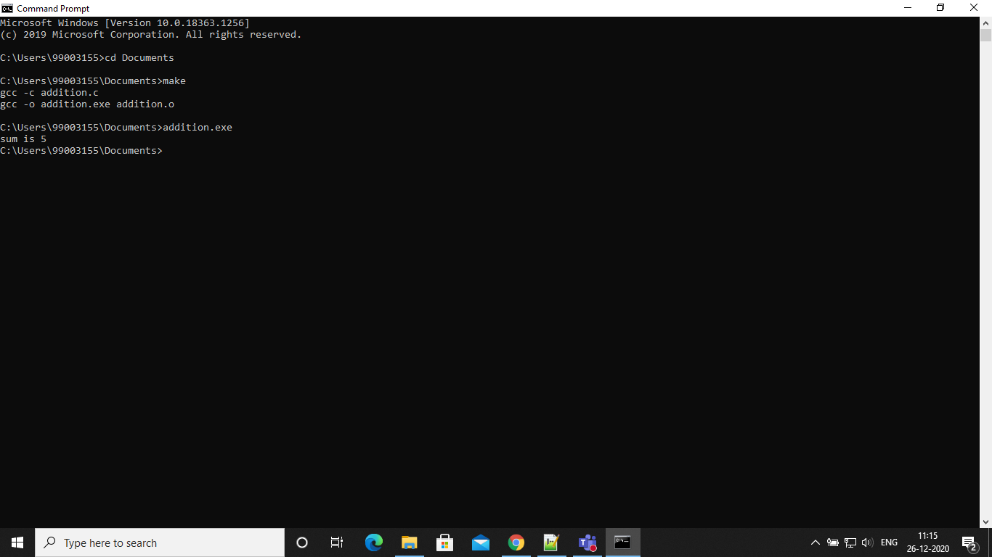

Fig1: Task 1

# TASK 2

* Linker script was created for one section of the memory
* Git bash was used

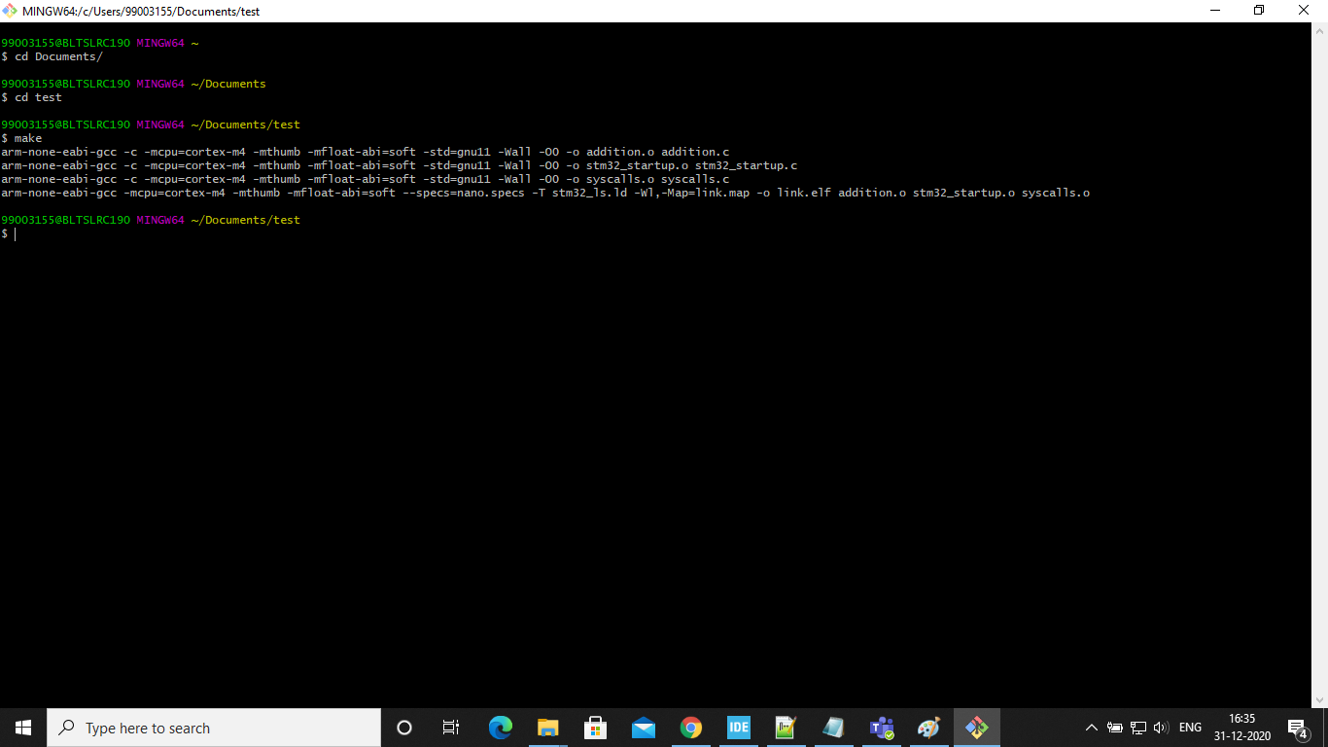

Fig 2: Task 2

# TASK 3

* Startup code generation
* Interrupt vector

Fig 3: Task 3

# 

# TASK 4

* Script for Makefile

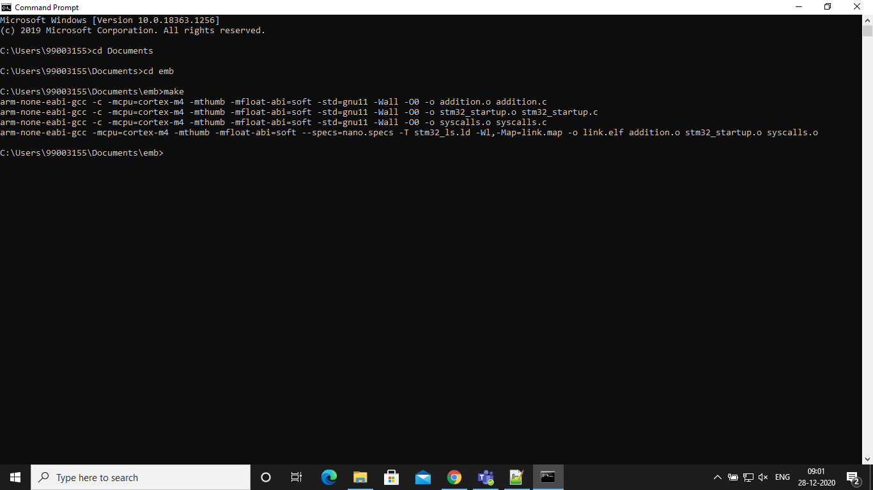

Fig 4: Task 4

# MINI PROJECT

## Human motion detection

Hardware requirements:

* STM32F407VGT6 discovery board
* PIR sensor
* Jumper wires
* cable

Software requirements:

* STM32CubeIDE

## Test plan

|  |  |  |  |
| --- | --- | --- | --- |
| **Test case ID** | **Input** | **Expected output** | **Actual output** |
| TC01 | No motion | Orange LED does not blink | Orange LED does not blink |
| TC02 | Movement of the hand | Orange LED blinks once | Orange LED blinks once |